Smart MCQ Solver Challenge
Project Report
Prepared by: Chinmayee Awale
Competition: Smart MCQ Solver Challenge (Kaggle)
Metric: Mean Average Precision at 3 (MAP@3)

1. Abstract / Executive Summary
This report documents the approach, experiments, and results for the Smart MCQ Solver Challenge, a Kaggle competition requiring participants to rank the three most probable correct answers, out of five options (A–E), for each multiple-choice question. Submissions are scored using Mean Average Precision at 3 (MAP@3).
Two models are documented in depth: a pretrained transformer (DeBERTa-v3-large) fine-tuned with LoRA, and a Siamese bidirectional LSTM (BiLSTM) built entirely from scratch. A third model, to complete the three-model comparison required by this report, is left as a placeholder pending further experimentation (Section 5.3).
The fine-tuned DeBERTa-v3-large + LoRA model reached a validation MAP@3 of 0.9983 (accuracy 0.9967) after 8 epochs, with only 0.60% of its parameters trainable. The from-scratch BiLSTM reached a validation MAP@3 of 0.9583 in a single train/validation split, improving to an out-of-fold MAP@3 of 0.9633 once option-shuffle augmentation, 5-fold cross-validation with bagging, and 5x test-time augmentation (TTA) were added — at roughly 1/560th the trainable parameter count of the transformer.
The main takeaway is that a large pretrained backbone achieves near-ceiling performance on this dataset with minimal fine-tuning, while a much smaller from-scratch model can still reach a strong MAP@3 through architecture and training-procedure choices alone — though EDA raised a caveat that both models may partly be exploiting an answer-length shortcut present in the data (Section 3.2), which future work should control for.

2. Introduction

2.1 Problem Statement
The Smart MCQ Solver Challenge provides a dataset of multiple-choice questions, each with a prompt and five answer options (A, B, C, D, E). For every question in the test set, a model must output up to three predicted labels in ranked order. Predictions are scored with MAP@3: a correct answer ranked first scores 1.0, ranked second scores 0.5, ranked third scores 1/3, and an unranked correct answer scores 0.

2.2 Project Objective
- Build and compare at least three distinct modeling approaches on the same train/test split and the same MAP@3 metric: one pretrained model fine-tuned for the task, one model built entirely from scratch, and one additional model of choice.
- Evaluate the trade-off between model scale/pretraining and achievable MAP@3 on this dataset.
- Gain hands-on experience with parameter-efficient fine-tuning (LoRA/PEFT) and with building a from-scratch sequence model and its training-time generalization techniques (data augmentation, k-fold bagging, test-time augmentation).

2.3 Report Structure
Section 3 covers the dataset and preprocessing. Section 4 covers tokenization strategy across the two implemented models. Section 5 documents each model's architecture and training. Section 6 compares performance across models. Section 7 concludes with learnings, challenges, and future work. Section 8 lists references.

3. Dataset & Preprocessing

3.1 Dataset Description
The competition provides train.csv (2,000 labeled questions: id, prompt, options A–E, and the correct answer letter) and test.csv (500 unlabeled questions in the same format). Both notebooks in this project used an 85/15 (DeBERTa) or 90/10 (LSTM) train/validation split, stratified by answer label.
Split | Rows | Notes
train.csv | 2,000 | id, prompt, A–E, answer
test.csv | 500 | id, prompt, A–E (unlabeled)

3.2 Exploratory Data Analysis (EDA)
A diagnostics pass over train.csv (from the LSTM notebook) surfaced the following:
- Answer letter distribution is mildly imbalanced: B 24.5%, C 23.0%, A 18.4%, D 17.9%, E 16.2%.
- 242 rows share a duplicate prompt with at least one other row, and 183 rows are fully duplicate (identical prompt and all five options).
- The correct option averages 181.9 characters in length, versus 162–167 characters average across each option column — the correct answer is, on average, somewhat longer than the distractors.
This last point is a genuine methodological caveat, not just a curiosity: a model can partially learn to predict “the longest option” rather than reasoning about content, which would inflate MAP@3 without reflecting real comprehension. This risk applies to both models in this report and is revisited in Section 7.3.

3.3 Data Preprocessing
For the BiLSTM pipeline, text was cleaned by stripping HTML tags and URLs and normalizing whitespace before tokenization; rows with all five options empty would be dropped (none were found empty in this dataset). For the DeBERTa pipeline, prompts and options were passed to the tokenizer largely as-is, relying on the pretrained tokenizer's subword handling rather than custom text cleaning.

3.4 Data Augmentation
The from-scratch BiLSTM's improved (5-fold) run added two augmentation strategies not present in the initial single-split run:
- Option-shuffle augmentation: during training only, the five options for each question are randomly reordered (with the label remapped accordingly) on every epoch, to prevent the model from learning positional shortcuts (e.g. “the answer is usually option B”).
- Test-time augmentation (TTA): at inference, each test question is scored under 5 random option orderings and the scores are averaged, reducing variance from any single ordering.

4. Tokenization Strategy

4.1 Primary Tokenizer Selection
The best-performing model, DeBERTa-v3-large, uses a SentencePiece unigram-language-model subword tokenizer, loaded via Hugging Face's AutoTokenizer for microsoft/deberta-v3-large.

4.2 Justification
Subword tokenization lets the model handle rare or domain-specific vocabulary in exam-style prompts without an out-of-vocabulary problem, and reuses the exact tokenizer the backbone was pretrained with — essential for the pretrained embeddings to be meaningful. Each question was encoded as five (prompt, option) sentence pairs, letting the model attend jointly over the prompt and a candidate option when scoring it.

4.3 Implementation Details
Tokenization was implemented as a batched Hugging Face datasets .map() call: for each question, the prompt is repeated five times and paired with each of the five options, truncated to a maximum length of 256 tokens with no static padding. A custom DataCollatorForMultipleChoice flattens the (batch, 5) structure into a single batch for the tokenizer's dynamic padding, then reshapes it back to (batch, 5, seq_len) before feeding the model — this keeps padding proportional to the longest sequence in each batch rather than a fixed max length.

4.4 Experimental Comparison
The from-scratch BiLSTM does not use a pretrained tokenizer or embeddings. Instead, it uses a simple regex-based word tokenizer combined with a frequency-based vocabulary (minimum frequency 2, capped at 30,000 tokens) built from the combined train and test text, yielding a vocabulary of 3,004 tokens. This was a deliberate choice consistent with “built from scratch”: no external pretrained resources were used anywhere in this model's pipeline, in contrast to DeBERTa's tokenizer and weights, which are both pretrained.

5. Modeling & Experimentation
Per this report's model requirements, this section documents one pretrained model, one model built from scratch, and one additional model of choice (currently a placeholder).

5.1 Model 1: Pretrained Model — DeBERTa-v3-large + LoRA

Architecture
DeBERTa-v3-large (He, Gao & Chen, 2021) extends BERT-style architectures with disentangled attention (separately encoding content and relative position) and an enhanced mask decoder, and is pretrained with ELECTRA-style replaced-token detection rather than masked-language-modeling, which the DeBERTaV3 paper shows improves downstream performance for a given parameter budget. The Hugging Face model card is available at huggingface.co/microsoft/deberta-v3-large. Here it is used via AutoModelForMultipleChoice, which adds a scoring head that produces one logit per option; the five logits are treated as classification logits over which option is correct.

Salient Points
The disentangled attention mechanism is well suited to this task because MCQ answer selection often depends on relative position and role of tokens (e.g. distinguishing the subject of the prompt from a candidate answer) rather than absolute position alone. Framing each option as a separate (prompt, option) pair lets the shared encoder produce a directly comparable compatibility score per option.

Fine-Tuning Strategy
Rather than full fine-tuning, LoRA (Low-Rank Adaptation; Hu et al., 2021) was used via Hugging Face PEFT to keep the backbone frozen and train only small low-rank adapter matrices, plus the new classifier/pooler heads:
Hyperparameter | Value
LoRA rank (r) | 16
LoRA alpha | 132
LoRA dropout | 0.1
Target modules | query_proj, value_proj (DeBERTa-v3-specific attention projections)
Modules fully trained | classifier, pooler
Optimizer / LR | AdamW (Trainer default), 5e-5
Batch size | 2 per device, grad. accumulation 8 (effective batch 16)
Epochs | 8
Weight decay / warmup | 0.05 / 10% warmup ratio
Max sequence length | 256 tokens
Trainable parameters | 2,623,489 of 437,686,274 total (0.60%)

A higher learning rate (5e-5) and more epochs (8) than typical full fine-tuning were used, consistent with common LoRA practice since only a small fraction of parameters are being updated. Training completed in approximately 26 minutes wall-clock for 8 epochs. No quantization was applied in this run.

Training Performance
Validation metrics were logged every epoch (metric_for_best_model = MAP@3, best checkpoint kept):
Epoch | Train Loss | Val Loss | Val Accuracy | Val MAP@3
1 | 26.85 | 3.059 | 0.510 | 0.662
2 | 23.95 | 2.182 | 0.703 | 0.812
3 | 11.44 | 0.739 | 0.897 | 0.934
4 | 7.93 | 0.363 | 0.957 | 0.970
5 | 5.60 | 0.250 | 0.973 | 0.985
6 | 4.25 | 0.192 | 0.987 | 0.993
7 | 3.17 | 0.147 | 0.997 | 0.998
8 (best) | 3.47 | 0.155 | 0.997 | 0.998

Final validation results at the best checkpoint (epoch 7–8): eval_loss = 0.147, eval_accuracy = 0.9967, eval_MAP@3 = 0.9983.

5.2 Model 2: Model Built From Scratch — Siamese BiLSTM

Architecture
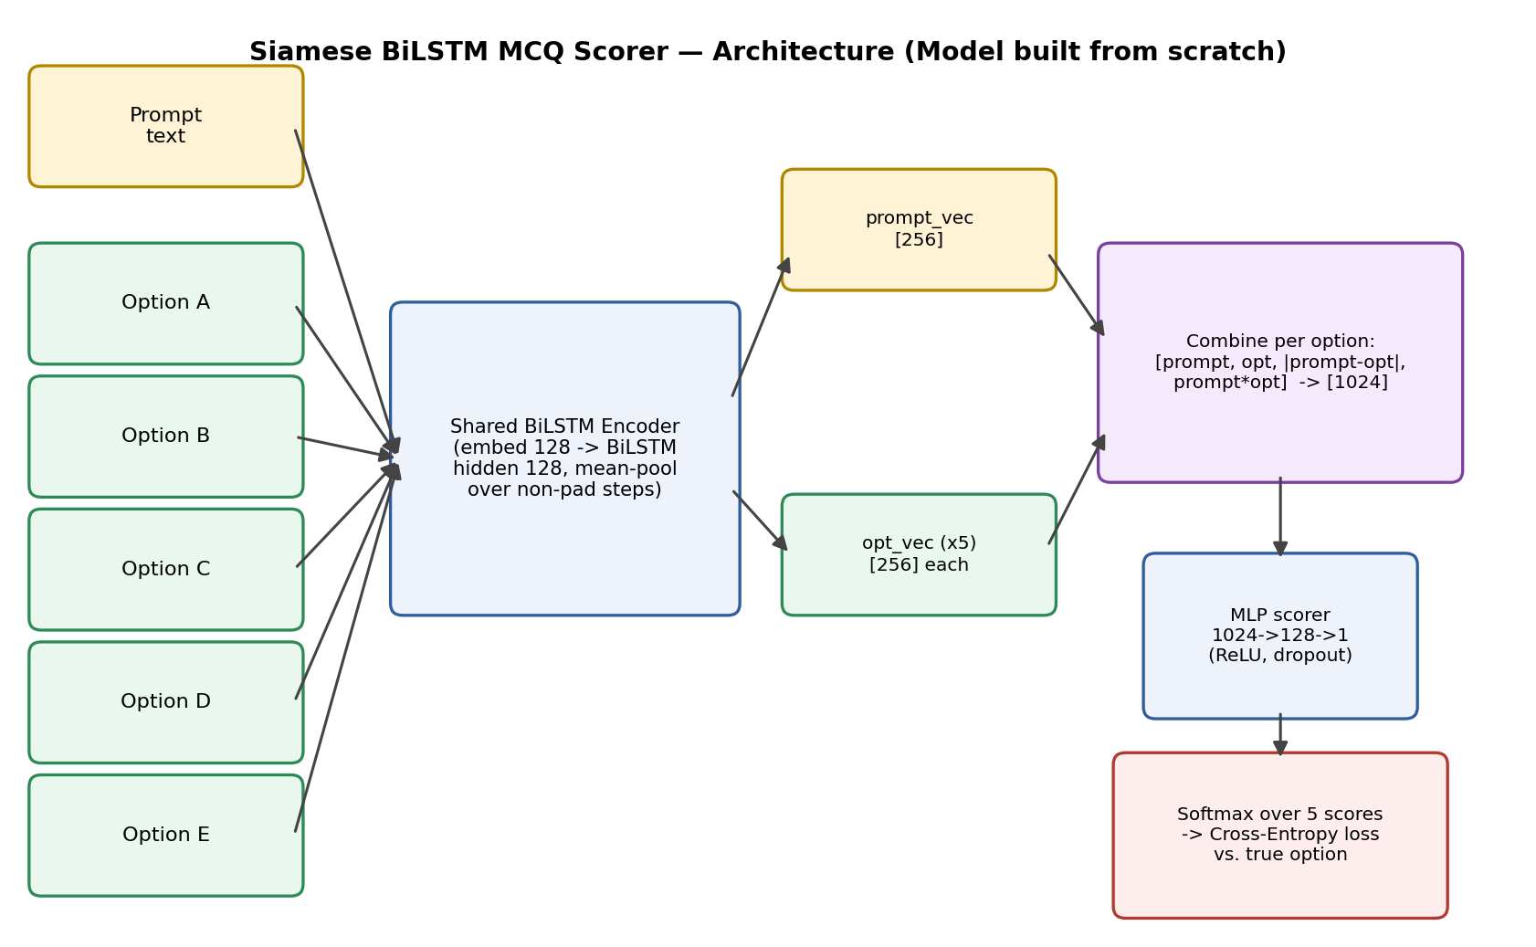
A shared bidirectional LSTM encoder (embedding dimension 128, hidden dimension 128, 1 layer, mean-pooled over non-padding timesteps) embeds the prompt and each of the five options independently using the same weights (a Siamese setup). For each option, the prompt vector and option vector are combined into a feature vector of [prompt, option, |prompt − option|, prompt × option] (concatenation of element-wise operations, 1,024 dimensions), which a small MLP (1024 → 128 → 1, ReLU, dropout 0.3) reduces to a single compatibility score. The five per-option scores are passed through softmax and trained with cross-entropy loss against the correct label. No component of this model uses pretrained weights — embeddings, encoder, and scorer are all randomly initialized and trained only on this competition's data, computed at roughly 0.78M parameters in total (embedding 3,004×128 + 1-layer BiLSTM(128) + MLP scorer), around 1/560th the trainable size of the LoRA-adapted DeBERTa model.

Salient Points
A sequence-based encoder is a reasonable from-scratch choice for MCQ answer scoring because it captures word order within the prompt and each option (unlike a bag-of-words baseline), while the Siamese weight-sharing keeps the parameter count small and forces the prompt and option representations into a shared embedding space where similarity/compatibility features (difference and product) are meaningful. Gradient clipping (max norm 5.0) was applied since LSTMs are prone to exploding gradients.

Training — Two Runs
This model was trained in two configurations to test whether cross-validation and augmentation close the gap to the transformer:
- Run A (single split): 90/10 stratified train/validation split, no option-shuffle augmentation, no TTA. Early-stopped at epoch 8 (patience 4) with best validation MAP@3 = 0.9583, macro-F1 = 0.9316.
- Run B (5-fold, augmented): 5-fold stratified cross-validation with bagging, option-shuffle augmentation during training, and 5x test-time augmentation. Out-of-fold MAP@3 = 0.9633, out-of-fold macro-F1 = 0.9396.
Fold | Best Val MAP@3 | Stopped at Epoch
1 | 0.9642 | 10
2 | 0.9600 | 7
3 | 0.9658 | 15
4 | 0.9671 | 7
5 | 0.9596 | 9
Out-of-fold (overall) | 0.9633 | —

The out-of-fold score (0.9633) is the more trustworthy estimate of the two, since it aggregates predictions each made on data unseen by that fold's model, rather than relying on a single train/validation split that could be optimistic or pessimistic by chance.

5.3 Model 3: Additional Model of Choice
[PLACEHOLDER] Not yet implemented. A weighted ensemble of Model 1 (DeBERTa-v3-large + LoRA) and Model 2 (Siamese BiLSTM) is a natural candidate given the large performance gap between them, but any additional architecture (e.g. a retrieval-augmented reranker, or a second pretrained backbone such as RoBERTa) would also satisfy this section. To be completed and added before submission.

6. Performance & Comparative Analysis

6.1 Evaluation Metrics
The competition's primary metric is Mean Average Precision at 3 (MAP@3). Accuracy (top-1 correct) and macro-F1 (LSTM notebook only) are reported as supporting metrics.

6.2 Training Performance
Per-epoch loss/metric curves are reported in tables in Sections 5.1 and 5.2 above, taken directly from each notebook's training logs. Neither run in this report produced exported Weights & Biases chart images (the DeBERTa run had wandb logging disabled; the LSTM run logged to wandb interactively but chart PNGs were not exported for this report) — pulling those visualizations would strengthen this section further.

6.3 Comparative Report
Model | Type | Trainable Params | Best MAP@3 | Other Metric | Notes
DeBERTa-v3-large + LoRA | Pretrained, fine-tuned | 2.62M / 437.7M (0.60%) | 0.9983 | Acc. 0.9967 | 8 epochs, ~26 min, single split
Siamese BiLSTM (Run A) | Built from scratch | ~0.78M (all trainable) | 0.9583 | Macro-F1 0.9316 | 8 epochs, single split, no aug/TTA
Siamese BiLSTM (Run B) | Built from scratch | ~0.78M × 5 folds | 0.9633 (OOF) | Macro-F1 0.9396 | 5-fold CV + option-shuffle aug + 5x TTA
Model 3 | TBD | — | — | — | Placeholder — see Section 5.3

The clearest trade-off in the table is scale versus effort: DeBERTa reaches near-ceiling MAP@3 (0.998) with 8 epochs of LoRA fine-tuning on top of ~438M pretrained parameters, but requires a GPU and the pretrained weights. The from-scratch BiLSTM, with roughly 1/560th as many trainable parameters and no pretrained weights or GPU dependency, still reaches ~0.96 MAP@3, and closes part of the remaining gap (0.9583 → 0.9633) purely through training procedure — 5-fold bagging, option-shuffle augmentation, and test-time augmentation — without changing the architecture at all. Given the answer-length signal noted in Section 3.2, some portion of both models' scores may reflect that shortcut rather than semantic reasoning; this is worth controlling for before treating either number as a ceiling on the task's real difficulty.

6.4 Kaggle Performance
[PLACEHOLDER] Final Kaggle leaderboard score and rank not yet recorded in the source notebooks — insert once the best submission.csv has been scored on the public/private leaderboard.

7. Conclusion & Future Work

7.1 Key Learnings
- Parameter-efficient fine-tuning (LoRA) can adapt a large pretrained transformer to a new task while training well under 1% of its parameters, and still reach near-ceiling performance in a handful of epochs.
- A carefully designed from-scratch model can close a meaningful part of the gap to a pretrained transformer through training procedure alone (cross-validation, augmentation, TTA) without any architecture change.
- Out-of-fold evaluation via k-fold CV gives a materially more trustworthy performance estimate than a single train/validation split, and is worth the added compute even for smaller models.

7.2 Challenges Faced
- Mild class imbalance in the answer distribution (B and C over-represented relative to E).
- 242 duplicate prompts and 183 fully duplicate rows in train.csv, which risk leakage between a naive train/validation split; the current split is label-stratified but not group-aware (duplicates of the same prompt can end up on both sides of the split).
- An apparent length bias where correct answers average ~10–12% longer than distractors, a possible shortcut-learning risk for both models.
- The DeBERTa model was evaluated on a single train/validation split, unlike the BiLSTM's 5-fold OOF evaluation — an asymmetry in evaluation rigor across the two models that limits a fully fair comparison.

7.3 Areas for Improvement
- Add group-aware (prompt-deduplicated) k-fold cross-validation to the DeBERTa run to match the rigor of the BiLSTM evaluation and remove any duplicate-prompt leakage risk.
- Run a length-controlled ablation (e.g. truncating/padding options to equal length) to quantify how much of either model's MAP@3 comes from the answer-length shortcut versus genuine reasoning.
- Complete Model 3 (Section 5.3), most likely a weighted ensemble of the transformer and BiLSTM predictions, or a retrieval-augmented reranker.
- Export Weights & Biases training curves as images for a more complete Section 6.2.
- Explore post-training quantization of the DeBERTa model for cheaper inference, given the near-ceiling accuracy leaves headroom to trade a little accuracy for speed.

8. References
He, P., Gao, J., & Chen, W. (2021). DeBERTaV3: Improving DeBERTa using ELECTRA-Style Pre-Training with Gradient-Disentangled Embedding Sharing. arXiv:2111.09543.
Hu, E. J., Shen, Y., Wallis, P., Allen-Zhu, Z., Li, Y., Wang, S., Wang, L., & Chen, W. (2021). LoRA: Low-Rank Adaptation of Large Language Models. arXiv:2106.09685.
Hugging Face. Model card: microsoft/deberta-v3-large.
Mangrulkar, S., Gugger, S., Debut, L., Belkada, Y., & Paul, S. PEFT: State-of-the-art Parameter-Efficient Fine-Tuning. Hugging Face.
PyTorch documentation: torch.nn.LSTM.
Kaggle. Smart MCQ Solver Challenge competition page.
Weights & Biases (wandb) documentation.

